Iterium Documentation

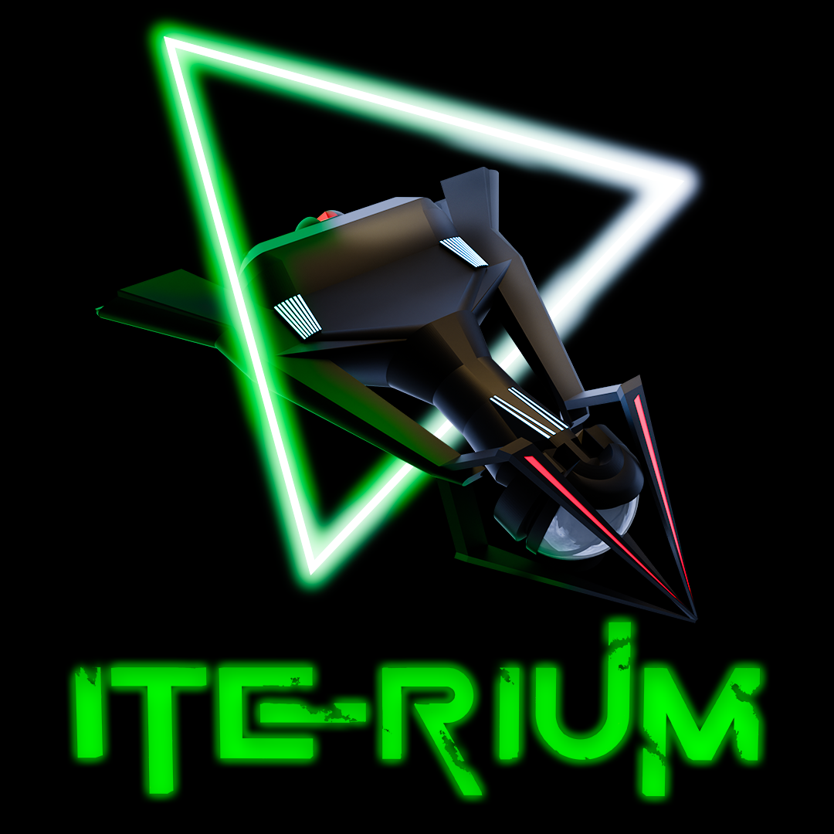

Revision: 2

Table of Contents

1. Game Overview 4

1.1. Game Story 5

1.2. Factions and ships 5

1.3. Controls 5

1.4 Scoring & Levels 6

1.5. Upgrading 6

1.6. Screenshots 6

1.6.1. Main Menu 6

1.6.2. Faction Selection 7

1.6.3. Game 7

1.6.4. Upgrades 8

1.6.5. High Score 8

1.6.6. Tutorial 9

1.6.7. Player Profile 9

1.6.8. Settings 10

1.6.9. Game Over 10

2. Unity Project 11

2.1. Project requirements 11

2.2. Folder Structure 11

2.3. Classes & Assemblies 12

2.4. Save System 13

2.4.1. Save files and methods 13

2.4.2. Path 13

2.4.3. Player data 14

2.4.4. Leaderboard data 14

2.4.5. File save handler 14

2.5. ScriptableObjects 15

2.5.1. SO_Leaderboard 15

2.5.2. SO_Player 15

2.5.3. SO_FactionList 15

2.5.4. SO_Faction 15

2.5.5. SO_Ship 15

2.5.6. SO_Bullet 15

2.5.7. SO_SFX 15

2.6. Managers 15

2.6.1. Singleton 15

2.6.2. GameManager 15

2.6.3. SoundManager 18

2.6.4. Bullet Pooling 19

2.6.5. Asteroid Pooling 20

2.6.6. Explosion Pooling 20

2.6.7. Input Manager 21

2.7. Gameplay Scripts 22

2.7.1. PlayerContoller 22

2.7.2. AIContoller 23

2.7.3. NPCContoller 24

2.7.4. BulletBase 24

2.7.5. Bullet 25

2.7.6. BulletAI 25

2.7.7. BulletNpc 26

2.7.8. Iterium 26

2.8. User Interface 27

2.8.1. Unity Style Sheets 27

2.8.2. UI Toolkit Documents 28

2.8.3. UI Scripts 28

2.9. Spawning 33

2.10. Builds 34

# Game Overview

|  |  |
| --- | --- |
| Genre | Top-down space shooter |
| Theme | 1980s Arcade |
| Perspective | 2.5D |
| Game engine | Unity (version 2021.3.15f1) |
| Scripting language | C# |
| Build targets | WebGL – Desktop browsers |
| License | Open source |
| Gameplay | The game follows a typical arcade genre where you try and survive as long as possible to gain the highest score and be entered on the leaderboard. Score can be achieved by shooting asteroids, collecting Iterium crystals, killing AI ships and Xoid flying Saucers.    At the start of the arena battle you will receive 3 ships (lives) and the battle will end when you lose all your lives. Asteroids do not do damage to your ship but will push your ship from course depending on the weight of the selected ship and size of the asteroid. Enemy fire can be destroyed with your own fire and damage can be reduced by deploying your shield.  When you or the AI are destroyed, a re-spawn delay will provide a short reprieve to the opponent to collect any floating crystals and rack up further points.    Iterium crystals are dropped randomly by destroying asteroids, crystals are used to upgrade the firepower, shield, and speed of your spaceship. Picking up crystals before your opponent is crucial to prevent them from also upgrading, increasing your maneuverability, offensive and defensive capabilities will give you the edge in battle.    There are 3 faction ships to choose from, each having their own balance of firepower, shields and speed. Each of the ship properties can be upgraded twice, the USSR Hammer is the heaviest ship and will be less impacted by asteroids while the lightest Chinese Rapier, although the fastest ship will struggle against flying debris. Each of the ship’s statistics can be viewed on the faction selection screen, including the status after upgrading. |

## Game Story

You are a space miner in the year 2055, traveling through the galaxy in search of rare and valuable Iterium crystals. These crystals are a crucial source of energy for space travel by an alien race called Xoids, and the demand for them is skyrocketing. Your goal is to collect as many of these crystals as you can and become the richest space miner in the galaxy.

As you travel from planet to planet, you hear rumors of a large asteroid belt rich in Iterium crystals. With excitement, you set your course for the belt and begin your search. The asteroids are treacherous, filled with danger at every turn, but the reward is worth the risk.

You equip your mining ship with the latest technology, including offensive weaponry with enough firepower to split asteroids. With each successful mining mission, your ship fills with Iterium crystals, but your journey is far from over. As you delve deeper into the asteroid belt, you encounter rival miners and Xoid UFOs who will stop at nothing to steal your valuable cargo. You must defend yourself and your ship from their attacks, using your maneuverability, firepower, and shields to fend them off.

You are determined to come out on top of the leaderboard, collecting as many crystals as you can and earning a place in the annals of space mining history. Will you become the richest space miner in the galaxy, or will you be defeated by the dangers of the asteroid belt? The fate of your journey rests in your hands.

## Factions and ships

The Sword belongs to the USA faction and is the most balanced of the 3 ships. The ships most impressive feature is its firepower, medium thrust capabilities with its shields being its weakest feature. Good balance of attack and maneuverability when fully upgraded. Weight is in the medium range and impacts how you are affected by the weight of an opposing asteroid.

The Hammer is the pride of the USSR faction and is built like a tank, very slow in maneuverability but makes up for it with its superb shields and medium fire power capabilities. A good ship for attack and defense during heated battles when fully upgraded. Heaviest weight of all the ships, impacts how you are affected by the weight of an opposing asteroid.  
  
The Rapier belongs to the Chinese faction, is sleek in design with blazingly fast thrusters. Firepower is the weakest of all ships with a medium shield capability. A good ship to avoid attack and quick Iterium collection. The lightest ship which impacts how you are affected by the weight of an opposing asteroid.

## Controls

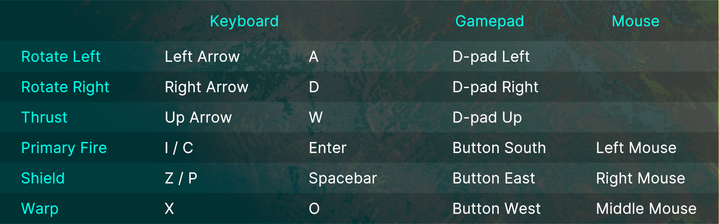

## 1.4 Scoring & Levels

Destroying NPC

Score + 1500

XP + 100

Destroying Player

Score + 500

XP + 50

Destroying Asteroid

Score + 50

XP + 10

Collecting Iterium

Score + 250

XP + 25

Points Bonus (Game Over scene)

At the end of each battle you will receive a points bonus calculated as (Iterium collected x 100) x level.

Leveling

Every 20000 XP gained.

## Upgrading

Upgrades are split into 3 different categories that can be upgraded twice each:

* Thrust
* Shields
* Firepower

You will need the required amount of Iterium indicated by each category slider on the upgrade screen. Iterium is dropped by destroying asteroids, there is a 20:1 chance of a drop.



## Screenshots

### Main Menu

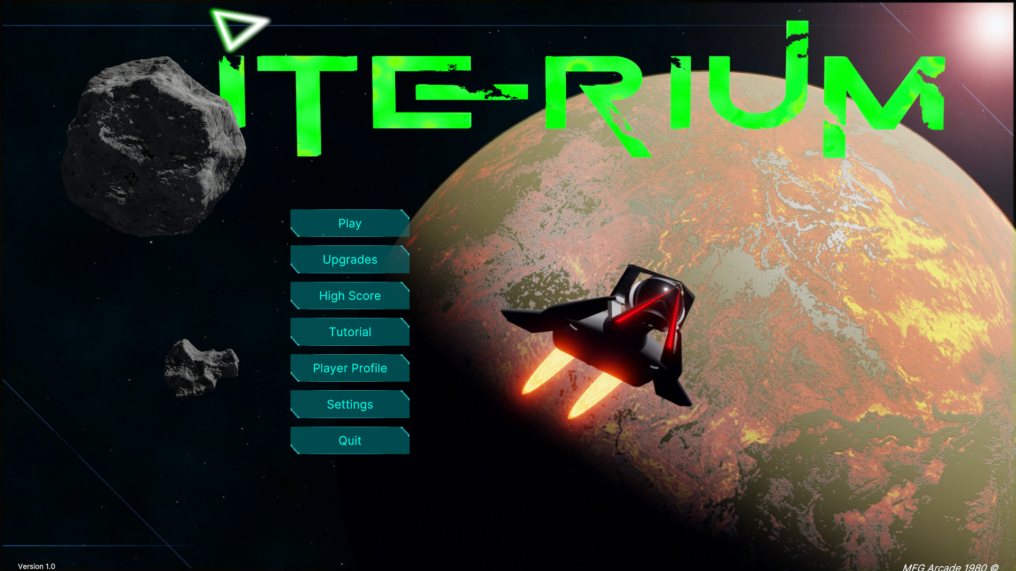

### Faction Selection

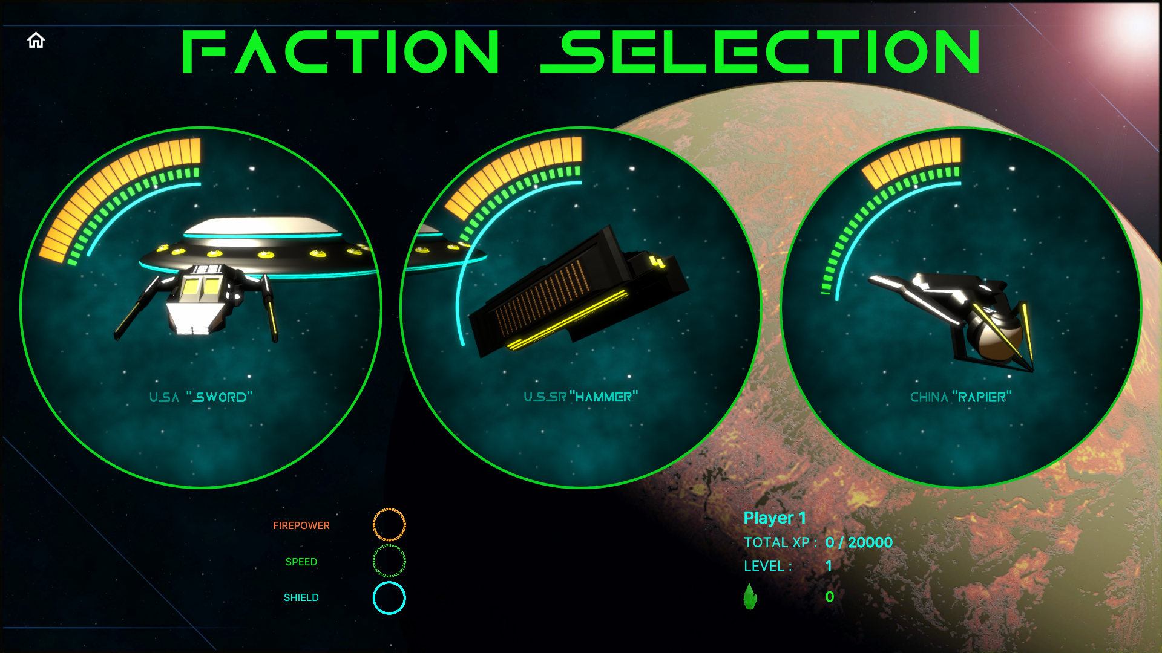

### Game

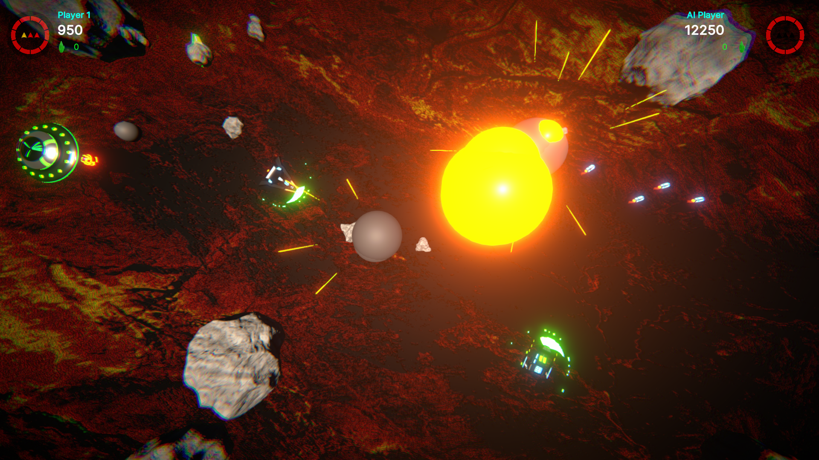

### Upgrades

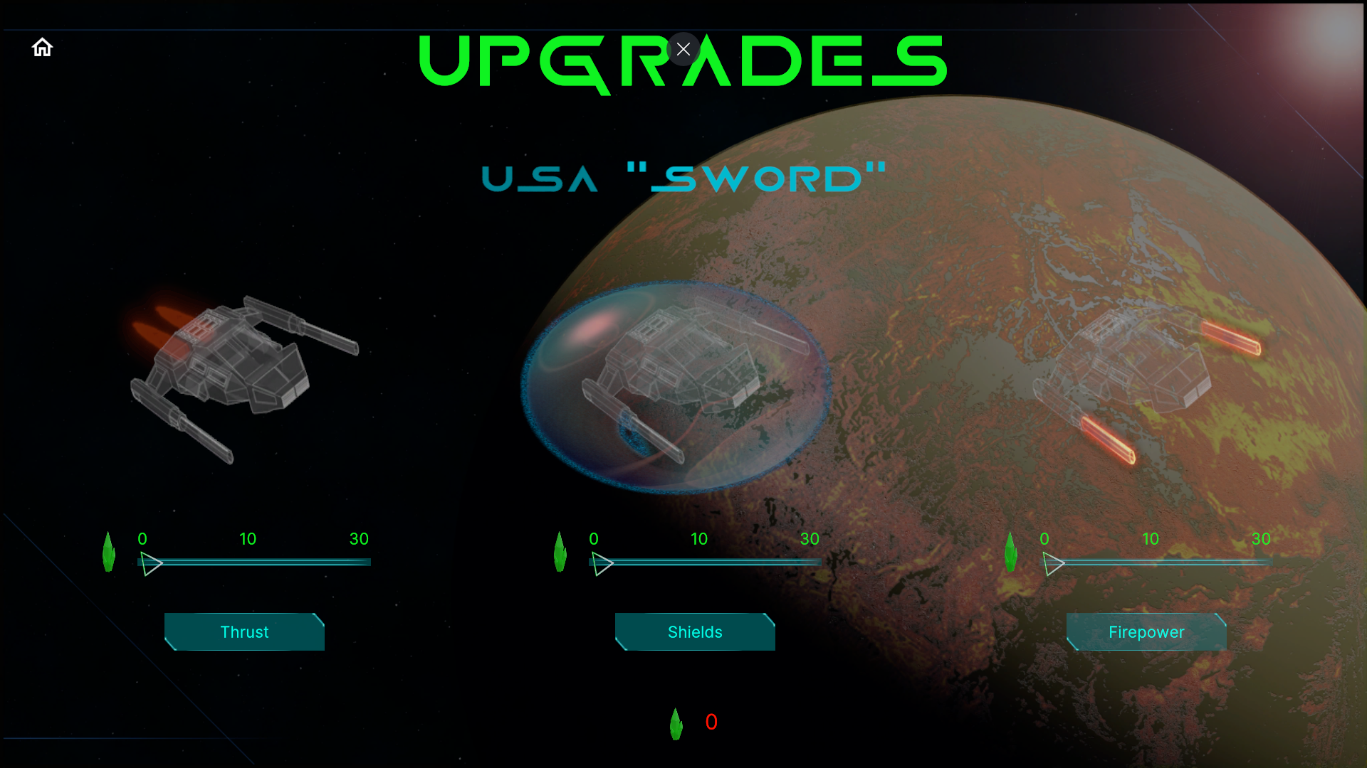

### High Score

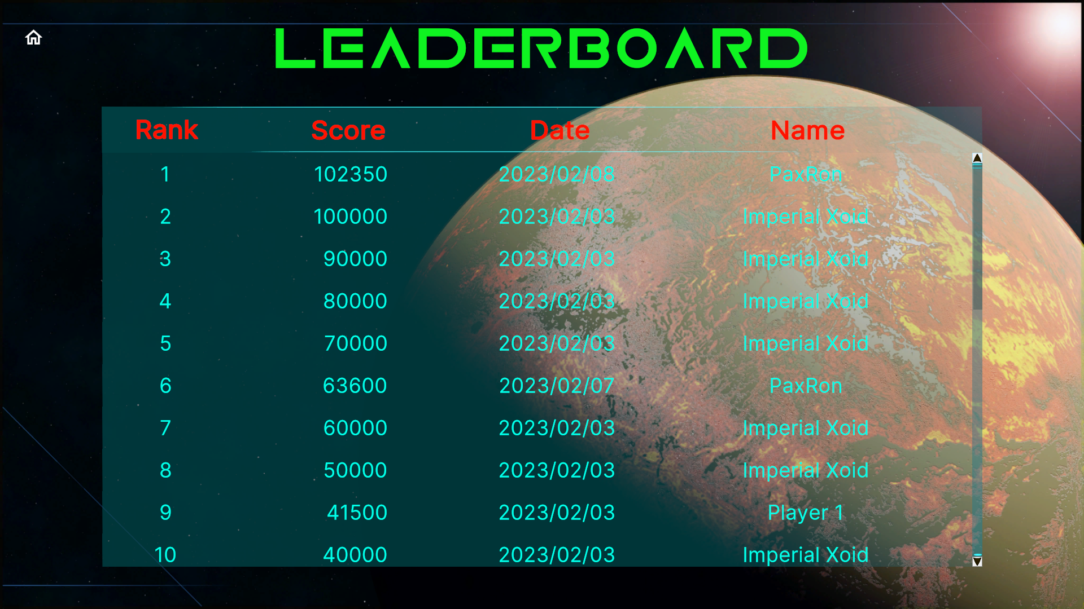

### Tutorial

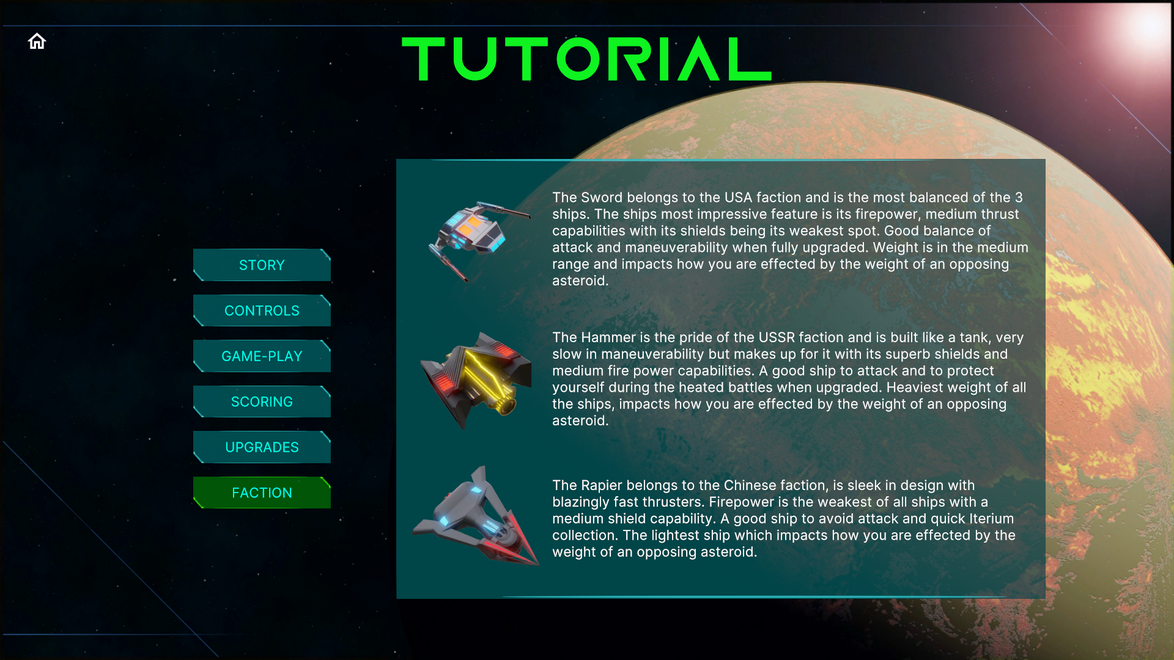

### Player Profile

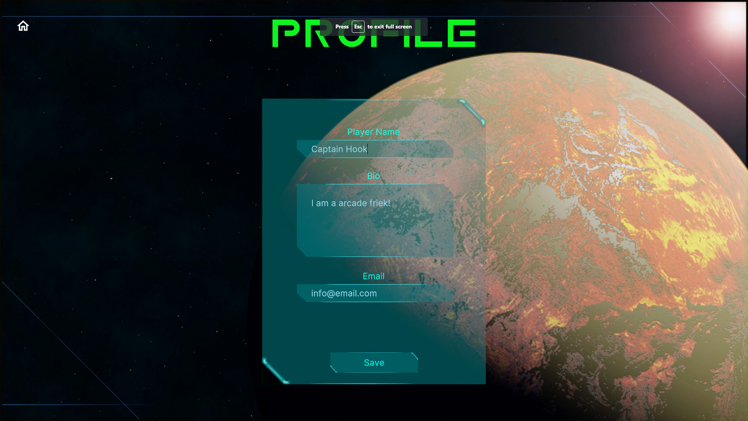

### Settings

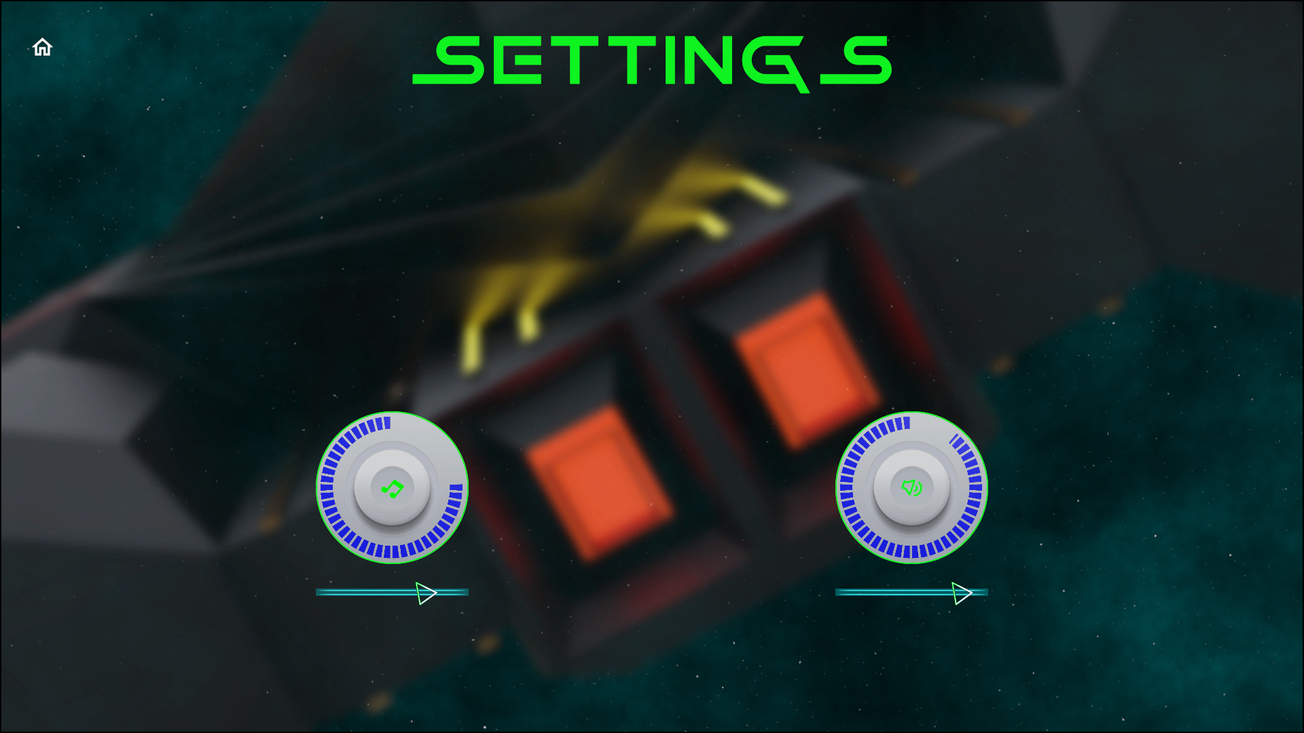

### Game Over

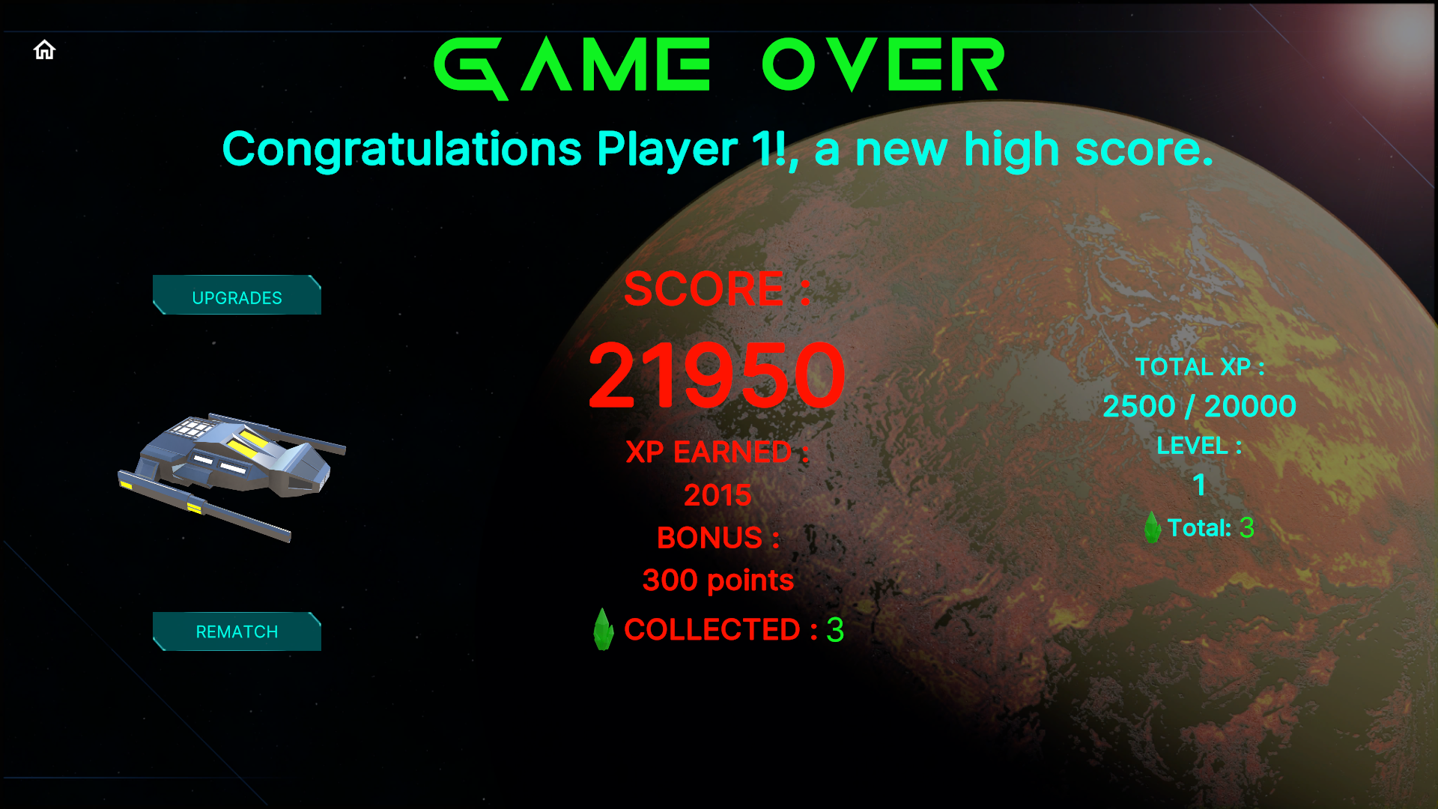

# Unity Project

## Project requirements

* Unity version 2021.3.15f1
* Render Pipeline: URP 12.1.8
* Input System (new)
* UI Toolkit
* Timeline
* Build platform: WebGL

## Folder Structure

|  |  |
| --- | --- |
| **Assets path sub folders** | **Description** |
| 3DModels | Ship and asteroid models |
| 3Dmodels/Bullets | Bullet models |
| 3Dmodels/Crystal | Iterium crystal model |
| 3Dmodels/Environment | Planet model |
| 3Dmodels/Materials | All model materials |
| 3Dmodels/Textures | All model textures |
| Animations | Animator/timeline files |
| Fonts | Font files |
| Images | Sprites for UI |
| Plugins | .wslib JavaScript plugin |
| Prefabs | All prefabs |
| RenderTextures | RenderTextures used to display models and shader graph progress bars |
| Scenes | All Unity scenes |
| ScriptableObjects | Created assets that hold the data |
| ScriptableObjects/Bullets | 3 levels of bullets per faction, Xoid bullet |
| ScriptableObjects/Factions | Factions – China, USA, USSR and Xoid |
| ScriptableObjects/Common | Common data and lists |
| ScriptableObjects/Common/Faction Types | Faction and NPC types |
| ScriptableObjects/Common/Lists | Lists of GameObjects and factions |
| ScriptableObjects/Common/Sound | Lists of sound effects and music |
| ScriptableObjects/Players | Player and AI data, holds the selected faction character SO |
| ScriptableObjects/Ships | Ship data, hold the ship bullet SO. |
| Scripts/ | All C# scripts |
| Scripts/Characters | Player controllers, leaderboard, bullets, Iterium |
| Scripts/General | Utility script like rotating an object |
| Scripts/Managers | Game and sound managers, object pooling |
| Scripts/Save System | Save/load system |
| Scripts/ScriptableObjects | ScriptableObject scripts |
| Scripts/Spawning | Player/AI/NPC spawners and de-spawners |
| Scripts/UI | UI scene scripts (UI Toolkit) |
| Settings | URP render pipeline assets |
| Settings/Import | Assets import templates |
| Settings/Input System | Input system asset (New Input System) |
| Settings/Renderer | URP renderers |
| Settings/Sound | Sound/music mixer |
| ShaderGraphs | Custom shaders for ship thrust effects and radial progress bars for the UI (health/shields/firepower/speed) |
| Sounds | All audio files |
| Sounds/Effects | Sound effect files |
| Sounds/Music | Music files |
| UI | UI Toolkit files |
| UI/Documents | UI Toolkit Documents (UXML) |
| Styles | UI Toolkit styles (uss) |
| UI Toolkit | UI Toolkit themes |
| WebGL Templates | WebGL custom loader (HTML) |

## Classes & Assemblies

Most classes are in the Iterium namespace and form part of the Assembly-CSharp assembly, the Scripts/General folder contains a “General” assembly definition asset and the Scripts/ScriptableObjects folder contains an “SO” assembly definition asset.

|  |  |  |  |
| --- | --- | --- | --- |
| **Class Name** | **Description** | **Derived From** | **Assembly** |
| AIController | Controls AI movement, shielding, firing etc. | MonoBehaviour | Assembly-Csharp |
| PlayerController | Controls player movement, shielding, firing etc. | MonoBehaviour | Assembly-Csharp |
| NPCController | Controls movement and firing for Xoid UFO | MonoBehaviour | Assembly-Csharp |
| BulletBase | Bullet base class, asteroid destruction, bullet explosions, Iterium drop etc. | MonoBehaviour | Assembly-Csharp |
| Bullet | Player bullet, collision detection | BulletBase | Assembly-Csharp |
| BulletAI | AI bullet, collision detection | BulletBase | Assembly-Csharp |
| BulletNpc | Xoid bullet, collision detection | BulletBase | Assembly-Csharp |
| Iterium | Collision detection for item collection | MonoBehaviour | Assembly-Csharp |
| SO_Leaderboard | List<LeaderboardItem> high score leaderboard | ScriptableObject | Assembly-Csharp |
| LeaderboardItem | Leaderboard item fields / row template |  | Assembly-Csharp |
| AsteroidPooling | Asteroid spawn/de-spawn object pooling | MonoBehaviour | Assembly-Csharp |
| BulletPooling | Bullet spawn/de-spawn object pooling | MonoBehaviour | Assembly-Csharp |
| ExplosionPooling | Explosion spawn/de-spawn object pooling | MonoBehaviour | Assembly-Csharp |
| Singleton | Singleton<T> base class | MonoBehaviour | Assembly-Csharp |
| GameManager | Player/AI objects, save/load, xp/level calculation, game settings, leaderboard, etc | Singleton<T> | Assembly-Csharp |
| SoundManager | Playing of sounds and music | Singleton<T> | Assembly-Csharp |
| InputManager | Device input for fire, thrust, rotate, shield etc. | MonoBehaviour | Assembly-Csharp |
| PlayMusic | Play sound effect by index from the SoundManager | MonoBehaviour | Assembly-Csharp |
| FileSaveHandler | Load/save serialized JSON data to a file, 3 save files for Player/AI/Leaderboard |  | Assembly-Csharp |
| SaveData | Player/AI save data fields |  | Assembly-Csharp |
| AISpawner | Spawn the AI prefab after a set time | MonoBehaviour | Assembly-Csharp |
| AsteroidSpawner | Spawn asteroid prefabs at set intervals | MonoBehaviour | Assembly-Csharp |
| DeSpawnAsteroid | Release asteroid to pool when leaving the screen | MonoBehaviour | Assembly-Csharp |
| DeSpawnExplosion | Release explosion after a set time | MonoBehaviour | Assembly-Csharp |
| GameOverSpawner | Spawn selected ship on the game over scene | MonoBehaviour | Assembly-Csharp |
| NPCSpawner | Spawn xoid UFO at set intervals | MonoBehaviour | Assembly-Csharp |
| PlayerSpawner | Spawn player prefab after a set time | MonoBehaviour | Assembly-Csharp |
| UI_Button | Generic button script to load a scene | MonoBehaviour | Assembly-Csharp |
| UI_FactionSelection | UI for the faction selection scene | MonoBehaviour | Assembly-Csharp |
| UI_Game | UI for gameplay scene | MonoBehaviour | Assembly-Csharp |
| UI_GameOver | UI for game over scene | MonoBehaviour | Assembly-Csharp |
| UI_Leaderboard | UI for the leaderboard scene | MonoBehaviour | Assembly-Csharp |
| UI_LoadUpgradeScene | Button script to load the upgrade scene | MonoBehaviour | Assembly-Csharp |
| UI_Profile | UI for the player profile scene | MonoBehaviour | Assembly-Csharp |
| UI_QuitGame | Button script to quit the application | MonoBehaviour | Assembly-Csharp |
| UI_Settings | UI for the settings scene | MonoBehaviour | Assembly-Csharp |
| UI_Tutorial | UI for the tutorial scene | MonoBehaviour | Assembly-Csharp |
| UI_Upgrade | UI for the upgrade scenes | MonoBehaviour | Assembly-Csharp |
| CameraZoom | Zoom camera when starting the play scene | MonoBehaviour | General |
| PlaySFXDelay | Play a AudioSource with a delay | MonoBehaviour | General |
| Rotate | Rotate any GameObject, example asteroids | MonoBehaviour | General |
| SO_Bullet | Bullet data, speed, firepower, prefab | ScriptableObject | SO |
| SO_Faction | Faction data, SO_Ship, factionId | ScriptableObject | SO |
| SO_FactionList | List<SO_Faction> of factions | ScriptableObject | SO |
| SO_GameObjects | List<GameObject> asteroids, explosions, Iterium | ScriptableObject | SO |
| SO_NPC | NPC data, Xoid ship | ScriptableObject | SO |
| SO_Player | Player/AI data, score, xp, health, lives, upgrades, etc | ScriptableObject | SO |
| SO_SFX | List<AudioClip> sound effects | ScriptableObject | SO |
| SO_Ship | Ship data, bullet, speed, shield power, prefab, etc | ScriptableObject | SO |
| SO_Types | Generic types or categories | ScriptableObject | SO |

## Save System

### Save files and methods

The system saves all data in 3 separate JSON files, namely Player.save, AI.save and Leaderboard.save. The file names can be changed on the GameManager inspector.

|  |  |
| --- | --- |
| GameManager Method() | Function |
| SaveGame | Save player and AI data to a JSON files |
| LoadGame | Load player and AI from a JSON files |
| SaveLeaderboard | Save leaderboard entries to a JSON file |
| LoadLeaderboard | Load leaderboard entries from a JSON file |

### Path

The save path is set as Application.persistentDataPath by passing the value to the FileSaveHandler constructor when the new object is created inside the GameManager Start() method.

### Player data

The SaveData class, contains all player data fields that are saved. Two objects are created from this class inside the GameManager and passed to the FileSaveHandler for saving…

|  |  |
| --- | --- |
| GameManager Object | Function |
| saveData | SaveData class object to store the players data for saving to file |
| saveDataAi | SaveData class object to store the AIs data for saving to file |

### Leaderboard data

The LeaderboardItem class contains the save data fields for each row in the leaderboard. ScriptableObject SO_Leaderboard contains a List<LeaderboardItem> that stores the leaderboard rows, this list is passed to the FileSaveHandler for saving.

|  |  |
| --- | --- |
| Object | Function |
| Leaderboard | ScriptableObject with a List<LeaderboardItem> used for storing the leaderboard items |
| leaderboard.Leaderboard | GameManager Leaderboard instance that is passed to the FileSaveHandler for saving the List<> to file |

### File save handler

The FileSaveHandler class writes the data to text files in JSON format.

|  |  |
| --- | --- |
| Method() | Function |
| Load | Load Player and AI data |
| Save | Save Player and AI |
| LoadLeadboard<T> | Load the leaderboard from file, converts array to a List<> before returned |
| SaveLeaderboard<T> | Save the leaderboard to file, converts List<> to array before saving |

The Unity JsonUtility does not serialize a List<> to JSON if it is the top node, the FileSaveHandler contains a JsonHelper class as a wrapper to wrap the leaderboard List<> inside a “Items” node. The List<> is cast to an array for serialization and cast back to a List<> before being returned by the FileSaveHandler.

|  |  |
| --- | --- |
| JsonHelper Method() | Function |
| FromJson<T> | Return a string from the de-serialised JSON |
| ToJson<T> | Converts to an array to serialise to JSON |
| ToJson<T> | Converts to an array to serialise to JSON (formatted) |

## ScriptableObjects

To reduce memory, aid testing and provide a designer friendly approach, data is stored inside ScriptableObject assets, this includes runtime data. Runtime data is loaded from the game save when the game starts, and updated data is saved at certain points back to the game save.

As summery of the main ScriptableObject game structure, the Player SO holds the players data including faction, the Faction SO holds the ship, the Ship SO holds the bullet and Bullet SO holds the bullet types as the player upgrades.

### SO_Leaderboard

The leaderboard asset contains a List<> that stores the high score rows. This list is passed to the FileSaveHandler during a game save.

### SO_Player

The player asset holds all the data for the Player/AI/Xoid – example health, level, upgrades, and faction.

### SO_FactionList

Contains a list of factions.

### SO_Faction

Contains data about the faction ID and the game can retrieve the ship data.

### SO_Ship

Contains data about thrust, turn speed, shield, prefab, and the game can retrieve the ships bullet data.

### SO_Bullet

Contains bullet data like speed, firepower and list of 3 bullet prefabs.

### SO_SFX

Contains a list of sound effects or music to play, has a method that returns a random clip.



## Managers

### Singleton

Base class for all singleton managers, namely GameManager and SoundManager classes. These 2 manager scripts are attached to the Managers prefab object and get instantiated from the main menu scene and live for the lifetime of the game.

### GameManager

The main class from where most game functions are managed – save/load game, Player/AI/NPC objects, leaderboard management, calculations for bonuses, XP, levels, upgrades etc.

|  |  |
| --- | --- |
| Exposed Property | Function |
| SaveFile | Name of the player game save file. |
| SaveFileAi | Name of the AI game save file. |
| SaveFileLeaderboard | Name of the leaderboard game save file. |
| Leaderboardsize | The number of rows the leaderboard can have. |
| Player | Player Scriptable Object for the game to access all player and faction data. |
| factions | List of all factions to assign a faction to a player when he selects a ship. |
| deathRespawnRate | Delay in seconds before a player or AI is re-spawned after death. |
| xpLevelSteps | XP to gain for the player to gain a new level. |
| maxLevel | The maximum number of achievable levels. |
| freeShip | Score needed to gain a free live, this only happens once per battle. |
| aiPlayer | The AI ScriptableObject for the game to access all AI data and faction data. |
| aiPermadeath | Does the AI have lives or continuously re-spawns which is the default. |
| npcPlayer | Xoid ScriptableObject for the game to access all NPC data. |
| iterium | Iterium ScriptableObject contains the Iterium prefab |
| iteriumChance | Chance for a splitting asteroid to drop a Iterium crystal. Default = 20:1 |
| speedLevel1 | Number of Iterium need to upgrade speed to level 2. |
| speedLevel2 | Number of Iterium need to upgrade speed to level 3. |
| shieldLevel1 | Number of Iterium need to upgrade shield to level 2. |
| shieldLevel2 | Number of Iterium need to upgrade shield to level 3. |
| firepowerLevel1 | Number of Iterium need to upgrade firepower to level 2. |
| firepowerLevel2 | Number of Iterium need to upgrade firepower to level 3. |
| Leaderboard | Leaderboard ScriptableObject containing a list of leaderboard rows. |

|  |  |
| --- | --- |
| Private Property | Function |
| fileSaveHandler | Instance of the FileSaveHandlder class to serialize data objects to a JSON file. Data objects passed are saveData, saveDataAI and leaderboard.Leaderboard |
| currentAIFaction | Current AI faction index, used to check if a AI respawn if a different faction so the AI bullet pool can be cleared. See SelectAiPlayer() method |

|  |  |
| --- | --- |
| Hidden Public Property | Function |
| saveData | Instance of the FileSaveHandlder class to serialize data objects to a JSON file. Data objects passed are saveData, saveDataAI and leaderboard.Leaderboard |
| saveAIData | Current AI faction index, used to check if a AI respawn if a different faction so the AI bullet pool can be cleared. See SelectAiPlayer() method |
| playerSpawner | Position of the spawner for respawns, position passed to this property by the spawner prefab on the first spawn |
| aiSpawner | Position of the spawner for respawns, position passed to this property by the spawner prefab on the first spawn |
| upgradeChnScene | China upgrade scene name |
| upgradeUsScene | USA upgrade scene name |
| UpgradeUssrScene | USSR upgrade scene name |
| isPlaying | Bool if the player is playing a game, if true don’t spawn player/AI from the co-routines when player exits the play before they spawn. |
| targetPlayer | Holds the spawned player, used by AI/NPC controllers to use as a target |
| targetAi | Holds the spawned AI, used by Player/NPC controllers to use as a target |
| targetNpc | Holds the spawned NPC, used by Player/AI controllers to use as a target |

|  |  |
| --- | --- |
| Method() | Function |
| OnEnable | Subscribe to events   * Bullet.BulletHit calls PlayerBulletHit() when player bullet hits a specific gameObject * BulletAI.BulletHit calls AiBulletHit() when AI bullet hits a specific gameObject * BulletNpc.BulletHit calls NpcrBulletHit() when NPC bullet hits a specific gameObject * Iterium.CollectedIterium calls CollectIterium() when player or AI collects and Iterium crystal |
| OnDisable | Un-subscribe from all events |
| Start | * Instantiate new FileSaveHandler * Load a game save * Initialise event listeners for player/AI bullet/shield/speed upgrades |
| SelectAiPlayer | Randomly select a faction for the AI at each spawn |
| ResetGame | Reset all data to game defaults |
| ResetArena | Reset player/AI score/health/lives/Iterium /XP for a new arena battle |
| spawnPlayer | Call co-routine to spawn player prefab |
| spawnAi | * Call SelectAIPlayer() to select a random faction * Call co-routine to spawn AI prefab |
| SpawnPlayerOverTime | IEnumerator to spawn player prefab with a set delay |
| SpawnAiOverTime | IEnumerator to spawn AI prefab with a set delay |
| RandomScreenPosition | Gets a random spawn position near a spawn point |
| CameraShake | Call co-routine to shake camera when player dies |
| Shake | IEnumerator to shake camera with time and magnitude |
|  |  |
|  |  |
|  |  |
|  |  |
| SaveGame | * Update SaveData object with values from the Player ScriptableObject asset * Update aiSaveData object with values from the AI ScriptableObject asset * Pass both objects to the fileSaveHandler.Save() method to serialise and save the data to a JSON file * Call SaveLeaderboard() to save the leaderboard |
| LoadGame | * Populate the SaveData object with the data loaded from the Player save file * Update the Player ScriptableObject asset with the SaveData data * Populate the aiSaveData object with the data loaded from the AI save file * Update the AI ScriptableObject asset with the aiSaveData data * Call LoadLeaderboard() to load the leaderboard * Assign the default faction to the player if this is a new game * Call UpgradeLevelSync to sync the loaded data to the upgrade levels for speed/shield/bullet |
| SaveLeaderboard | Pass the leaderboard.Leaderboard (ScriptableObject) property of the GameManager to the fileSaveHandler for saving to a JSON file |
| LoadLeaderboard | * Load the leaderboard data from file into the leaderboard.Leaderboard property (ScriptableObject) of the GameManager * Call InitLeaderboard() |
| InitLeaderboard | If there are no current leaderboard rows (new game) then create new rows by the leaderboardSize property with the Xoid faction, multiplying each row score by 10 000 |
| AddLeaderboardItem | Called from the GameOver scene to add the player or AI score to the leaderboard when a high score is achieved |
| SortLeaderboard | Sort the leaderboard by score by descending, for a high score the last row is always checked to see if the player scorer is higher |
| GameOver | Load the GameOver scene |
| SceneUpgrade | Load the appropriate upgrade screen depending on the player currently selected faction. |
| MainMenu | Load the MainMenu scene |
| OnApplicationQuit | * Call SaveGame() * If WebGL build load a specific webpage * Else Application.Quit() is called |
| CalculateXP | Calculate if a player or AI increases in level after gaining XP in the arena. Level steps are calculated on the xpLevelSteps property |
| CalculateIterium | Add Iterium collected in the arena to the player/AI total Iterium value |
| CalculatePlayerBonus | Calculate how much points bonus a player earns after an arena. player.IteriumCollected * 100 * player.Level |
| CalculateAiBonus | Calculate how much points bonus a AI earns after an arena.  aiPlayer.IteriumCollected * 100 * aiPlayer.Level |
| BulletLvlChanged | Keeps the Player object bullet upgrade values in sync with the current upgrade level |
| ShieldLvlChanged | Keeps the Player object shield upgrade values in sync with the current upgrade level |
| SpeedLvlChanged | Keeps the AI object speed upgrade values in sync with the current upgrade level |
| BulletLvlChangedAi | Keeps the Player object bullet upgrade values in sync with the current upgrade level |
| ShieldLvlChangedAi | Keeps the AI object shield upgrade values in sync with the current upgrade level |
| SpeedLvlChangedAi | Keeps the AI object speed upgrade values in sync with the current upgrade level |
| UpgradeLevelSync | Sync the loaded game save upgrade data to the game upgrade properties for the player and AI |

|  |  |
| --- | --- |
| Event Subscriptions | Function |
| Bullet.BulletHit | Calls PlayerBulletHit() – adds score and XP for the Player when the bullet hits an asteroid, AI or NPC, AI takes damage |
| BulletAI.BulletHit | Calls AiBulletHit() - adds score and XP for the AI when the bullet hits the asteroid, Player or NPC, Player takes damage |
| BulletNpc.BulletHit | Calls NpcBulletHit() – Player and AI take damage |
| Iterium.CollectIterium | Calls CollectIterium() – Adds score and XP to the Player and AI when collecting an Iterium crystal |

### SoundManager

All the sound effects and music, AudioSources, volume is managed from this class.

|  |  |
| --- | --- |
| Exposed Property | Function |
| asteroidExplosion | ScriptableObject list of sound clips for asteroid explosions |
| shipExplosion | ScriptableObject list of sound clips for ship explosions |
| effects | ScriptableObject list of sound clips for sound effects |
| music | ScriptableObject list of sound clips for music |
| audioSourceNumber | Number of AudioSources to create dynamically for use by sound effects. Music has its own single dedicated AudioSource and is not included in this. |
| mixerMaster | Audio mixer group for the master |
| mixerMusic | Audio mixer group for music |
| mixerSfx | Audio mixer group for sound effects |

|  |  |
| --- | --- |
| Private Property | Function |
| audiosourceSfx[] | An array of audioSources used for sound effects |
| audiosourceMusic | Single Audiosource used for the music |

|  |  |
| --- | --- |
| Method() | Function |
| Start | Set the effects and music mixer volumes that are loaded from game save into the Player object when the game starts |
| Awake | * Create an array of AudioSources to be used as round robin for sound effects * Assign the sound effects mixer group to the above AudioSources * Add an AudioSource for music * Assign the music mixer group to the above AudioSource |
| PlayAsteroidExplosion | Play a random sound from the AsteroidExplosions ScriptableObject List<AudioClip> |
| PlayShipExplosion | Play a random sound from the ShipExplosions ScriptableObject List<AudioClip> |
| PlayEffect | Play a sound by index from the Effects ScriptableObject List<AudioClip> |
| PlayMusic | Play a music by index from the Music ScriptableObject List<AudioClip>, method has properties to loop, stop and delay the clip |
| GetAudioSourceSfx | Returns an available AudioSource from the audiosourceSfx[] array |

### Bullet Pooling

Bullets fired from the player, AI and NPC are object pooled to increase performance. The GameManager provides the bullet prefabs to spawn from the player, aiPlayer and npcPlayer properties, depending on the faction that is selected and the level of the bullet.

|  |  |
| --- | --- |
| Exposed Property | Function |
| capacity | Default pool capacity of bullets for the player |
| maxCapacity | Maximum pool capacity of bullets for the player |
| capacityAi | Default pool capacity of bullets for the AI |
| maxCapacityAi | Maximum pool capacity of bullets for the AI |
| capacityNpc | Default pool capacity of bullets for the NPC |
| maxCapacityNpc | Maximum pool capacity of bullets for the NPC |
| bulletPoolPlayer | Player bullet pool (static) |
| bulletPoolAi | AI bullet pool (static) |
| bulletPoolNpc | NPC bullet pool (static) |

|  |  |
| --- | --- |
| Method() | Function |
| Awake | * Init a new bulletPoolPlayer pool object * Init a new bulletPoolAi pool object * Init a new bulletPoolNpc pool object |
| PoolNew_Player | Return a new instantiated Player bullet taking the Player bullet level |
| PoolNew_Ai | Return a new instantiated AI bullet taking the AI bullet level |
| PoolNew_NPC | Return a new instantiated NPC bullet |
| PoolGet | Get a bullet from the pool |
| PoolReturn | Return a bullet back to the pool |
| PoolDestroy | Destroy a bullet in the pool |

### Asteroid Pooling

Asteroids are spawned from a pool to increase performance. Properties exposed in the inspector are as follows…

|  |  |
| --- | --- |
| Exposed Property | Function |
| capacity | Default pool capacity of spawned asteroids |
| maxCapacity | Maximum pool capacity of spawned asteroids |
| asteroids | Asteroids prefab to be spawned |
| asteroidPool | Asteroid pool (static) |

|  |  |
| --- | --- |
| Method() | Function |
| Awake | Init a new asteroidPool pool object |
| PoolNew | Return a new instantiated asteroid prefab |
| PoolGet | Get an asteroid from the pool |
| PoolReturn | Return an asteroid back to the pool |
| PoolDestroy | Destroy an asteroid in the pool |

### Explosion Pooling

Explosions are spawned from a pool to increase performance. Properties exposed in the inspector are as follows…

|  |  |
| --- | --- |
| Exposed Property | Function |
| capacity | Default pool capacity of explosions to spawn |
| maxCapacity | Maximum pool capacity of explosions to spawn |
| explosion | Explosion prefab to spawn |
| explosionPool | Explosions pool (static) |

|  |  |
| --- | --- |
| Method() | Function |
| Awake | Init a new explosionPool pool object |
| PoolNew | Return a new instantiated explosion prefab |
| PoolGet | Get an explosion from the pool |
| PoolReturn | Return an explosion back to the pool |
| PoolDestroy | Destroy an explosion in the pool |

### Input Manager

**InputManager class is the main class to use the InputSystem for all actions except the Pause action, this is actioned from the UI_Game class.**

**Input System (Input Actions)**Single action map called “Player” with the following actions.

* Movement and firing
* Shield
* Thrust
* Warp
* Pause

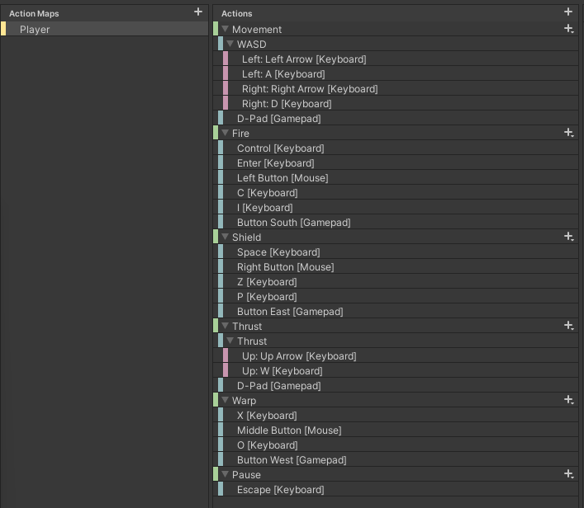



## Gameplay Scripts

Scripts that control character (player/AI/NPC) movement, firing, bullets, and Iterium collection etc.

### PlayerContoller

Control the player ship movement, thrusting, firing, shielding, and warping.

|  |  |
| --- | --- |
| Private Property | Function |
| input | InputManager component for input |
| firePosition | Empty GameObject on the ship from where bullets are spawned |
| shield | Plane with a Shader Graph material, gameObject is disabled at start, enabled when shielding |
| shieldCooldown | Used as a timer to limit when the player can deploy the shield |
| IsShielding | Bool to indicate if the ship is shielding to limit continuous shielding |
| thrusters | Plane with a Shader Graph material, gameObject is disabled at start, enabled when thrusting |
| isThrusting | Bool to indicate if the ship is thrusting to limit continuous thrusting |
| rigidBody | Used to add velocity to the ship |

|  |  |
| --- | --- |
| Medthod() | Function |
| Start | Get components for…   * input – InputManager for user input * shield – transform child under the ship at index 0, plane with a Shader Graph material to give a shield effect * thrusters – transform child under the ship at index 1, plane with Shader Graph material to display a thruster effect * firePosition – transform child under the ship at index 2, position from where the bullets will fire from * rigidBody – velocity is added from thrusting |
| Update | Calls methods to operate the player ship   * Rotate() * Fire() * Shield() * Warp() |
| FixedUpdate | Calls methods to move the ship   * Thrust() |
| Rotate | Rotation of the ship left or right |
| Fire | Fire a bullet from the bullet pool, the velocity of the bullet is the factions ship speed multiplied by the Player bullet level |
| Thrust | * Thrusts the ship forward * Enables/disables the thrust effects – plane as child on the ship * Adds force to the rigidBody using the faction ships thrust multiplied by the Player speed level |
| Shield | * Enables/disables the shield effects – plane as child on the ship * Play a sound from an AudioSource attached to the shield plane * Starts a co-routine ShieldTime() as a count-down timer * Start the shield cooldown so the player cannot deploy the shield again until the cooldown is finished |
| Warp | Warp the player to a random position near the player spawner |
| ShieldTime | IEnumerator that waits until the shield time is up and disables the shield |
| BulletHit | * Calculates the damage to the ship health when hit by a bullet * Takes into account the bullet firepower and shield strength * Calls co-routine DestroyShip() if the health reaches zero, also decreasing the Player lives |
| DestroyShip | IEnumerator to destroy the ship   * Instantiate 3 explosion effects from the explosions pool * Play the ship explosion sound effect from the SoundManager * Call the SpawnPlayer() method of the GameManager passing in the required delay time * Destroy the ship gameObject |
| OnBecameInvisible | When the ship leaves the screen it returns (wraps) the ship to the opposite side of the screen |

### AIContoller

Control the AI ship movement, thrusting, firing, shielding.

|  |  |
| --- | --- |
| Exposed Property | Function |
| fireDelay | Delay before the AI starts firing when spawning |
| fireInterval | Interval that the AI fires a bullet |
| descisionCycle | How many shots are fired at a target before making another decision on who to target (Player or NPC) |

|  |  |
| --- | --- |
| Private Property | Function |
| firePosition | Empty GameObject on the ship from where bullets are spawned |
| shield | Plane with a Shader Graph material, gameObject is disabled at start, enabled when shielding |
| IsShielding | Bool to indicate if the ship is shielding to limit continuous shielding |
| thrusters | Plane with a Shader Graph material, gameObject is disabled at start, enabled when thrusting |
| isThrusting | Bool to indicate if the ship is thrusting to limit continuous thrusting |
| rigidBody | Used to add velocity to the ship |
| shots | How many shots have been fired to make a target decision if equal to the descisionCycle |
| attackNPC | Must the AI attack the NPC, 50/50 decision or the player could be dead |

|  |  |
| --- | --- |
| Medthod() | Function |
| Start | Get components for…   * shield – transform child under the ship at index 0, plane with a Shader Graph material to give a shield effect * thrusters – transform child under the ship at index 1, plane with Shader Graph material to display a thruster effect * firePosition – transform child under the ship at index 2, position from where the bullets will fire from * rigidBody – velocity is added from thrusting * InvokeRepeating for firing * InvokeRepeating for shielding, using the shield cooldown value as the interval |
| Update | Calls methods to operate the player ship   * Rotate() |
| FixedUpdate | Calls methods to move the ship   * Thrust() |
| Rotate | Rotation of ship to either target the Player or NPC |
| Fire | Shoots a set number of bullets in a decision round, then decides again on its target, taking into account who is on the screen regards Player and NPC |
| Thrust | * Thrusts the ship forward * Enables/disables the thrust effects – plane as child on the ship * Adds force to the rigidBody using the faction ships thrust multiplied by the AI speed level |
| Shield | * Enables/disables the shield effects – plane as child on the ship |
| ShieldTime | IEnumerator that waits until the shield time is up and disables the shield |
| BulletHit | * Calculates the damage to the ship health when hit by a bullet * Takes into account the bullet firepower and shield strength * Calls co-routine DestroyShip() if the health reaches zero, also decreasing the AI lives |
| DestroyShip | IEnumerator to destroy the ship   * Instantiate 3 explosion effects from the explosions pool * Play the ship explosion sound effect from the SoundManager * Call the SpawnAi() method of the GameManager passing in the required delay time * Destroy the ship gameObject |
| OnBecameInvisible | When the ship leaves the screen it returns (wraps) the ship to the opposite side of the screen |

### NPCContoller

Control the NPC ship (Xoid UFO) movement and firing.

|  |  |
| --- | --- |
| Exposed Property | Function |
| fireDelay | Delay before the NPC starts firing when spawning |
| fireInterval | Interval that the NPC fires a bullet |

|  |  |
| --- | --- |
| Private Property | Function |
| target | Random number to select the target of player or AI |

|  |  |
| --- | --- |
| Medthod() | Function |
| Start | Get components for…   * InvokeRepeating for firing |
| Fire | Decides randomly on its target, taking into account who is on the screen regards Player and NPC |
| OnBecameInvisible | When the ship leaves the screen it gets destoryed |

### BulletBase

|  |  |
| --- | --- |
| Exposed Property | Function |
| sfxIndex | Sound effect to play from the Effects ScriptableObject, via the SoundManager.Instance.PlayEffect(sfxIndex) method |

|  |  |
| --- | --- |
| Method() | Function |
| AsteroidHit | * Splits and scales the Asteroid when hit by a bullet * Can be split 3 times into a random 2-4 pieces. * Asteroid weight is also adjusted accordin to the split size. * 20:1 chance to spawn an Iterium crystal * Call asteroid explosion sound from SoundManager * Call ReleaseBullet() |
| OnBecameInvisible | * Call ReleaseBullet() |
| BulletExplosion | * Call bullet explosion sound from SoundManager * Instantiate an explosion visual effect from pool * Call ReleaseBullet() |
| ReleaseBullet | * Releases bullet back to pool, empty in the base class and is overwritten individually on each player/AI/NPC bullet |

### Bullet

Players bullet, hit detection.

|  |  |
| --- | --- |
| Exposed Property | Function |
| BulletHit | static event to broadcast that it has hit an object passing the object name in a string |

|  |  |
| --- | --- |
| Method() | Function |
| OnTriggerEnter | * Case “Asteroid” update player score and XP by Invoking the BulletHit event, split asteroid and instantiate a bullet explosion * Case “AI” update player score and XP, AI health by Invoking the BulletHit event, instantiate a bullet explosion * Case “NPC” update player score and XP by Invoking the BulletHit event, destroy NPC and instantiate a bullet explosion |
| ReleaseBullet | * Release bullet to pool |

### BulletAI

AI bullet, hit detection.

|  |  |
| --- | --- |
| Exposed Property | Function |
| BulletHit | static event to broadcast that it has hit an object passing the object name in a string |

|  |  |
| --- | --- |
| Method() | Function |
| OnTriggerEnter | * Case “Asteroid” update AI score and XP, Player health by Invoking the BulletHit event, split asteroid and instantiate a bullet explosion * Case “Player” update AI score and XP by Invoking the BulletHit event, instantiate a bullet explosion * Case “NPC” update AI score and XP by Invoking the BulletHit event, destroy NPC and instantiate a bullet explosion * Case “Bullet” Release bullet to pool |
| ReleaseBullet | * Release bullet to pool |

### BulletNpc

NPC bullet, hit detection.

|  |  |
| --- | --- |
| Exposed Property | Function |
| BulletHit | static event to broadcast that it has hit an object passing the object in a string |

|  |  |
| --- | --- |
| Method() | Function |
| OnTriggerEnter | * Case “Asteroid” split asteroid and instantiate a bullet explosion * Case “Player” Invoke BulletHit event to update Player health, instantiate a bullet explosion * Case “AI” Invoke BulletHit event to update AI health , instantiate a bullet explosion * Case “Bullet” Release colliding bullet to pool |
| ReleaseBullet | * Release bullet to pool |

### Iterium

Attached to a drop Iterium prefab, collection of the crystal by player or AI.

|  |  |
| --- | --- |
| Exposed Property | Function |
| CollectIterium | static event to broadcast that the Iterium crystal was collected, passing the object name in a string |

|  |  |
| --- | --- |
| Method() | Function |
| OnTriggerEnter | * Case “Player” update Player score, XP and Iterium collected by Invoking the CollectIterium event * Case “AI” update AI score, XP and Iterium collected by Invoking the CollectIterium event |



## User Interface

The only UI used is the project is the Unity Toolkit and the look and feel of the game can be changed through the Unity style sheets (uss).

### Unity Style Sheets

|  |  |
| --- | --- |
| ***MainStyle USS Classes*** | **Function** |
| *.button* | Buttons throughout UI |
| *.text* | Used across multiple UI documents to affect text’s |
| *.footer* | Footer text used in Main Screen |
| *.menu-button* | Home screen menu sprite |
| *.image-button* | Images on Faction Selection Screen |
| *.header* | Headers on all UI documents |
| *.text-score* | Leaderboard Item text |
| *.score-panels* | Leaderboard score panel adjustment |
| *.text-scoreHeading* | Leaderboard title headings |
| *.progress-slider* | Sliders in all documents |
| *.progress-slider-text* | Upgrade document slider text |
| *.button:hover* | Transitions for buttons on hover |
| *.button:active* | Transitions for buttons when active |
| *.button:focus* | Transitions for buttons when it has focus |
| *.unity-base-text-field__input* | Base input text fields |
| *.unity-base-field__input* | Base input text fields |
| *.unity-text-field__input* | Base input text fields |
| *.gridcontroller* | Tutorial document Control Panel alignments and spacing |
| *.ship-icon* | Tutorial document Scoring Panel ship sprites |
| *.controller-text* | Tutorial document text |
| *.unity-base-slider__dragger* | Sprite for slider handle |
| *.unity-base-slider__tracker* | Sprite for slider background |
| *.unity-scroller__slider* | Leaderboard scroller sprite |
| *.unity-scroller__low-button* | Image on vertical scrollbar for the Leaderboard scroll view |
| *.unity-scroller__high-button* | Image on vertical scrollbar for the Leaderboard scroll view |
| *#scrollViewHS .unity-scroller--vertical .unity-base-slider__dragger* | The scrollbar dragger image and background colour for the Leaderboard scroll view |

### UI Toolkit Documents

|  |  |
| --- | --- |
| UI Toolkit Documents | Function |
| FactionSelection | Used on the FactionSelection scene, contains 4 Render Textures in the UI for the Shader Graph progress bars of the 3 ships and the legend |
| GameOver | Used on the GameOver scene, contains 1 Render Texture to display the player ship |
| Leaderboard | Used on the Leaderboard scene, contains a scroll view named scrollViewHS |
| LeaderboardItem | Used as a row template inside the Leaderboard scrollViewHS |
| MainMenu | Used for the menu on the MainMenu scene |
| Play | Used to display the player/AI health, lives and Iterium collected, pause menu |
| Settings | Used on the Settings scene, contains 2 Render Textures to display the volume/effects radial shader graph progress bars. |
| Tutorial | Used on the Tutorial scene, various tutorial panels that are shown/hidden via script depending which tutorial button is clicked |
| UpgradeChina | Used on the UpgradeChina scene, has 3 sliders (thrust/shields/firepower) with a corresponding upgrade button, the sliders are disabled and are moved by a script when an upgrade is actioned. |
| UpgradeUSA | Used on the UpgradeUSA scene, has 3 sliders (thrust/shields/firepower) with a corresponding upgrade button, the sliders are disabled and are moved by a script when an upgrade is actioned. |
| UpgradeUSSR | Used on the UpgradeUSSR scene, has 3 sliders (thrust/shields/firepower) with a corresponding upgrade button, the sliders are disabled and are moved by a script when an upgrade is actioned. |
| UserProfile | Used on the UserProfile screen, various input boxes, the information is saved when the save button is clicked |

### UI Scripts

Refer to the Classes & Assemblies section for additional reference.

#### UI_Button

General button UI script to load a scene.

|  |  |
| --- | --- |
| Exposed Property | Description |
| sceneName | Holds the scene to load |
| buttonName | Button element – load the scene when clicked |

#### UI_FactionSelecton

FactionSelection scene UI script to allow the player to see the firepower/shield/speed stats of each ship and to select a shift for the arena.

|  |  |
| --- | --- |
| Exposed Property | Description |
| sceneName | Holds the Play scene to load |
| chinaFaction | Button element – Selects the China faction and updates the Player.Faction property of the GameManager |
| usaFaction | Button element – Selects the USA faction and updates the Player.Faction property of the GameManager |
| ussrFaction | Button element – Selects the USSR faction and updates the Player.Faction property of the GameManager |
| playerStatsText | Label element – Profile name of the player |
| playerXPTotal | Label element – Players total XP value |
| playerLevel | Label element – Players current level |
| playerIteriumTotal | Label element – Players total Iterium value |
| shipChn | Chinese ship ScriptableObject asset to get the ships base firepower/shield/speed |
| shipUs | USA ship ScriptableObject asset to get the ships base firepower/shield/speed |
| shipUssr | USSR ship ScriptableObject asset to get the ships base firepower/shield/speed |
| progressChnFirepower | Plane with Shader Graph material, China firepower radial progress bar, set float on the progress bar material (“_RemovedSeg”) |
| progressChnSpeed | Plane with Shader Graph material, China speed radial progress bar, set float on the progress bar material (“_RemovedSeg”) |
| progressChnShield | Plane with Shader Graph material, China shield radial progress bar, set float on the progress bar material (“_RemovedSeg”) |
| progressUsFirepower | Plane with Shader Graph material, US firepower radial progress bar, set float on the progress bar material (“_RemovedSeg”) |
| progressUsSpeed | Plane with Shader Graph material, US speed radial progress bar, set float on the progress bar material (“_RemovedSeg”) |
| progressUsShield | Plane with Shader Graph material, US shield radial progress bar, set float on the progress bar material (“_RemovedSeg”) |
| progressUssrFirepower | Plane with Shader Graph material, USSR firepower radial progress bar, set float on the progress bar material (“_RemovedSeg”) |
| progressUssrSpeed | Plane with Shader Graph material, USSR speed radial progress bar, set float on the progress bar material (“_RemovedSeg”) |
| progressUssrShield | Plane with Shader Graph material, USSR shield radial progress bar, set float on the progress bar material (“_RemovedSeg”) |

#### UI_Game

Game scene UI script to display the health/Iterium collected, and lives of the player/AI.

|  |  |
| --- | --- |
| Exposed Property | Description |
| sceneName | Holds the MainMenu scene to load |
| player1 | TextElement to display player profile name |
| scorePlayer1 | TextElement to display player score |
| iteriumPlayer1 | TextElement to display the player stage collected Iterium |
| player2 | TextElement to display AI profile name |
| scorePlayer2 | TextElement to display AI score |
| iteriumPlayer2 | TextElement to display the AI stage collected Iterium |
| ship1Player1 | VisualElement to display the player 1st ship life image |
| ship2Player1 | VisualElement to display the player 2nd ship life image |
| ship3Player1 | VisualElement to display the player 3rd ship life image |
| ship4Player1 | VisualElement to display the player 4th (extra life) ship life image |
| ship1Player2 | VisualElement to display the AI 1st ship life image |
| ship2Player2 | VisualElement to display the AI 2nd ship life image |
| ship2Player2 | VisualElement to display the AI 3rd ship life image |
| progressPlayerHealth | Plane with Shader Graph material, player radial health progress bar, set float on the progress bar material (“_RemovedSeg”) |
| progressAiHealth | Plane with Shader Graph material, AI radial health progress bar, set float on the progress bar material (“_RemovedSeg”) |
| pause | VisualElement – pause panel with 2 buttons |
| exitGame | Button element – pause button to exit the stage and return to MainMenu scene |
| continueGame | Button element – pause button to close pause panel and continue stage |

#### UI_GameOver

Game Over scene UI script, displays the users arena score, collected XP, Iteruim, high score music, custom message based on how good the score is.

|  |  |
| --- | --- |
| Exposed Property | Description |
| gameScene | Holds the Play scene to load |
| playerScore | Label to display player stage score |
| playerIterium | Label to display player stage collected Iterium |
| playerIteriumTotal | Label to display player total Iterium |
| message | Label to display custom score related congratulations message |
| rematch | Button element to re-start the Play scene |
| playerXPTotal | Label to display player total XP |
| playerXPEraned | Label to display player stage XP |
| playerLevel | Label to display player level, level progression is calculated in this scene |
| playerBonus | Label to display player stage score bonus, (Iterium collected x 100) x level |

#### UI_Leaderboard

Leaderboard scene UI script to display the top player/AI high scores by score ranking

|  |  |
| --- | --- |
| Exposed Property | Description |
| scoreRow | VisualTreeAsset – leaderboard row document template |
| rank | Label to display leaderboard item ranking |
| score | Label to display leaderboard item score |
| date | Label to display leaderboard item date |
| playerName | Label to display player name |

#### UI_LoadUpgradeScene

Loads the appropriate faction upgrade scene depending on the players currently selected faction.

|  |  |
| --- | --- |
| Exposed Property | Description |
| upgradeButton | Button element to ask the GameManger to load the upgrade scene of the player selected faction |

#### UI_Profile

PlayerProfile scene UI script, display and save input for player name, bio and email address.

|  |  |
| --- | --- |
| Exposed Property | Description |
| sceneName | Holds the MainMenu scene to load |
| playerName | TextField input for the player name |
| bio | TextField input for the player bio description |
| email | TextField input for the player email address |
| save | Button element to save input field data and load the MainMenu scene |

#### UI_QuitGame

Attached to the quit button to call the Game Manager OnApplicationQuit() method, which saves the games and redirects to a chosen webpage.

|  |  |
| --- | --- |
| Exposed Property | Description |
| buttonName | Button element to exit the game |

#### UI_Settings

Settings scene UI script to display the current music and sound effects volumes, adjusts the volumes when the appropriate sliders are changed.

|  |  |
| --- | --- |
| Exposed Property | Description |
| musicSlider | Slider element to change the music volume |
| soundslider | Slider element to change the sound effects volume |
| musicIcon | VisualElement to rotate the music icon image |
| soundIcon | VisualElement to rotate the sound effects icon image |
| progressMusic | Plane with Shader Graph material, music radial progress bar, set the float on the progress bar material (“_RemovedSeg”) |
| progressSound | Plane with Shader Graph material, sound effects radial progress bar, set the float on the progress bar material (“_RemovedSeg”) |
| audioMixer | Sound Audio Mixer asset to set the volume of the music float (“Music”) and sound effects float (“Sound”) |

#### UI_Tutorial

Tutorial scene UI scripts to hide/show tutorial VisualElements depending on what tutorial buttons are selected.

|  |  |
| --- | --- |
| Exposed Property | Description |
| buttonStory | Button element to show the story tutorial panel |
| controls | Button element to show the controls tutorial panel |
| gameplay | Button element to show the gameplay tutorial panel |
| scoring | Button element to show the scoring tutorial panel |
| upgrades | Button element to show the upgrades tutorial panel |
| faction | Button element to show the factions tutorial panel |
| storyPanel | VisualElement of the story panel |
| controlsPanel | VisualElement of the controls panel |
| gameplayPanel | VisualElement of the gameplay panel |
| scoringPanel | VisualElement of the scoring panel |
| upgradesPanel | VisualElement of the upgrades panel |
| factionPanel | VisualElement factions panel |

#### UI_Upgrade

Faction upgrade scene, upgrades the ships firepower, speed and shield if the player has the required Iterium.

|  |  |
| --- | --- |
| Exposed Propertt | Description |
| thrustSlider | Slider element to indicate the current thrust upgrade |
| shieldSlider | Slider element to indicate the current shield upgrade |
| firePowerSlider | Slider element to indicate the current firepower upgrade |
| thrustUpgrade | Button element to upgrade the thrust if the player has the indicated Iterium |
| shieldUpgrade | Button element to upgrade the shield if the player has the indicated Iterium |
| firepowerUpgrade | Button element to upgrade the firepower if the player has the indicated Iterium |
| iteriumAmount | Label element to indicate the player total Iterium |
| thrustLevel1 | Label element to show the required Iterium needed for the thrust level 1, set in the GameManager class |
| thrustLevel2 | Label element to show the required Iterium needed for the thrust level 2, set in the GameManager class |
| shieldLevel1 | Label element to show the required Iterium needed for the shield level 1, set in the GameManager class |
| shieldLevel2 | Label element to show the required Iterium needed for the shield level 2, set in the GameManager class |
| firepowerLevel1 | Label element to show the required Iterium needed for the firepower level 1, set in the GameManager class |
| firepowerLevel2 | Label element to show the required Iterium needed for the firepower level 2, set in the GameManager class |



## Spawning

The spawning folder holds all the spawning scripts, these are attached to an empty prefab and placed where you want the player/AI/NPC to spawn. The asteroids have 4 spawning empty game objects in the scene and a target object.

|  |  |
| --- | --- |
| Script Name | Description |
| PlayerSpawner | Player spawner that has a spawnTime property to set the delay in seconds of the spawn. The game GameManager has a SpawnPlayer(spawnTime) method that is called and does the spawning. The position of the spawner is also passed to the GameManager playerSpawner property so it knows where to do a re-spawn later |
| AISpawner | AI spawner that has a spawnTime property to set the delay in seconds of the spawn. The game GameManager has a SpawnAI(spawnTime) method that is called and does the spawning. The position of the spawner is also passed to the GameManager aiSpawner property so it knows where to do a re-spawn later |
| NPCSpawner | Spawns the Xoid NPC UFO periodically, setting the target and random speed   * spawnInterval property is the time before each spawn * minSpeed is the min range of the random speed selection * maxSpeed is the max range of the random speed selection   The player is the first target, if the player is dead, it will target the AI, if they are both dead it will fly towards the center of the screen |
| AsteroidSpawner | This script is attached to 4 game objects by default, but more can be added, and target a target game object (AsteroidTarget) game object in the scene for direction. Random speed is selected and the AsteroidPooling class selects a random prefab to spawn.     * spawnInterval property is the time before each spawn * minSpeed is the min range of the random speed selection * maxSpeed is the max range of the random speed selection * spawnOnceOnly allows only 1 asteroid to spawn * target is the AnsteroidTarget game object that the asteroid moves towards |
| DeSpawnAsteroid | Releases the asteroid back to the pool when the asteroid leaves the camera view |
| DeSpawnExplosion | Releases the explosion effect back to the pool after a set time delay |
| GameOverSpawner | Spawn the players currently selected ship on the Game Over scene. |



## Builds

Build settings platform must be set to WebGL

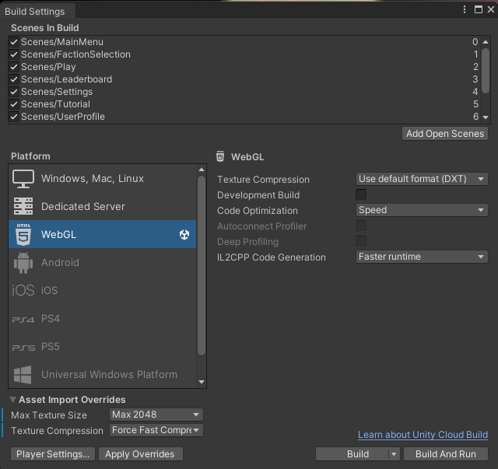

Change the background, game and studio logos for the splash page under Player Settings.

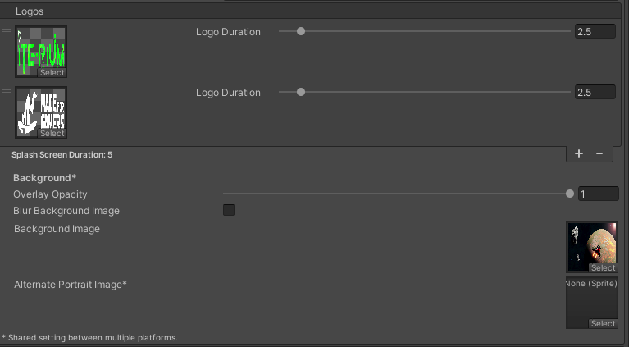

Also, under Player Settings / Publishing Settings, change the compression accommodated by your web server, depending on the server OS and web server you may need to include an appropriate config file in the root for the compression and handling of the wasm files and also mime types such as .mem and .data.

See Unity documentation here on web server config files - [Link](https://docs.unity3d.com/Manual/webgl-server-configuration-code-samples.html)  
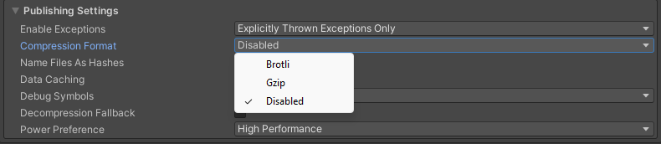

You can change the HTML loading template under the folder WebGL Templates / MFG

Finally build the project and copy the build folder to you web server and enter the URL to the website, sometimes you would have to add the Index.html (case sensitive) at the end of the URL for it to work, for example GitHub pages.